**GLOBAL WAVE CLIMATE AND WAVE ENERGY DATA AT KELP FORESTS**

By: Borja G Reguero (1) & I.J. Losada (2)

1. Department of Ocean Sciences, University of California, Santa Cruz, CA, USA
2. Environmental Hydraulics Institute of Cantabria, University of Cantabria, Spain

# Introduction

This document briefly describes the wave climate at the locations of kelp forests in Krumhansl et al.

# Methods

1. The global wave data corresponds to (Reguero et al., 2012) and the wave energy estimates along with their temporal variability to (Reguero et al., 2015)
2. Each kelp forest coordinate is associated to the closest offshore time series (allowing for a maximum 3 degrees distance) , where we calculate different statistics and long term trends
3. The resutts are provided in a xls table that includes:
   1. Tab ‘Statistics’ includes wave climate statistics:
      1. Hs mean: mean significant wave height (see Fig1)
      2. Hs mean variation range: range of variation between the minimum and maximum within months.
      3. Hs 95% percentile: 95% percentile of significant wave height
      4. Mean Wave Power: Mean wave energy in kw/m
      5. Variation range in mean wave power: range of variation between the minimum and maximum within months.
   2. Time series of Annual mean Hs and Wave power, by coordinate of kelp forest, in independent tabs.
4. We calculated long-term trends and also separated by decades, since there are strong discrepancies between wave energy within decades due to the interannual variability - see (Reguero et al., 2015). These results are not included in this brief for the interest of simplicity.

# Results

* Figs 1 to 3 shows the spatial maps of 95% percentile of significant wave height, mean wave power and variation range of the wave energy.
* Fig. 4 shows one sample time series of wave energy calculated at each kelp forest, including the long term trend and the 5-yr moving average.

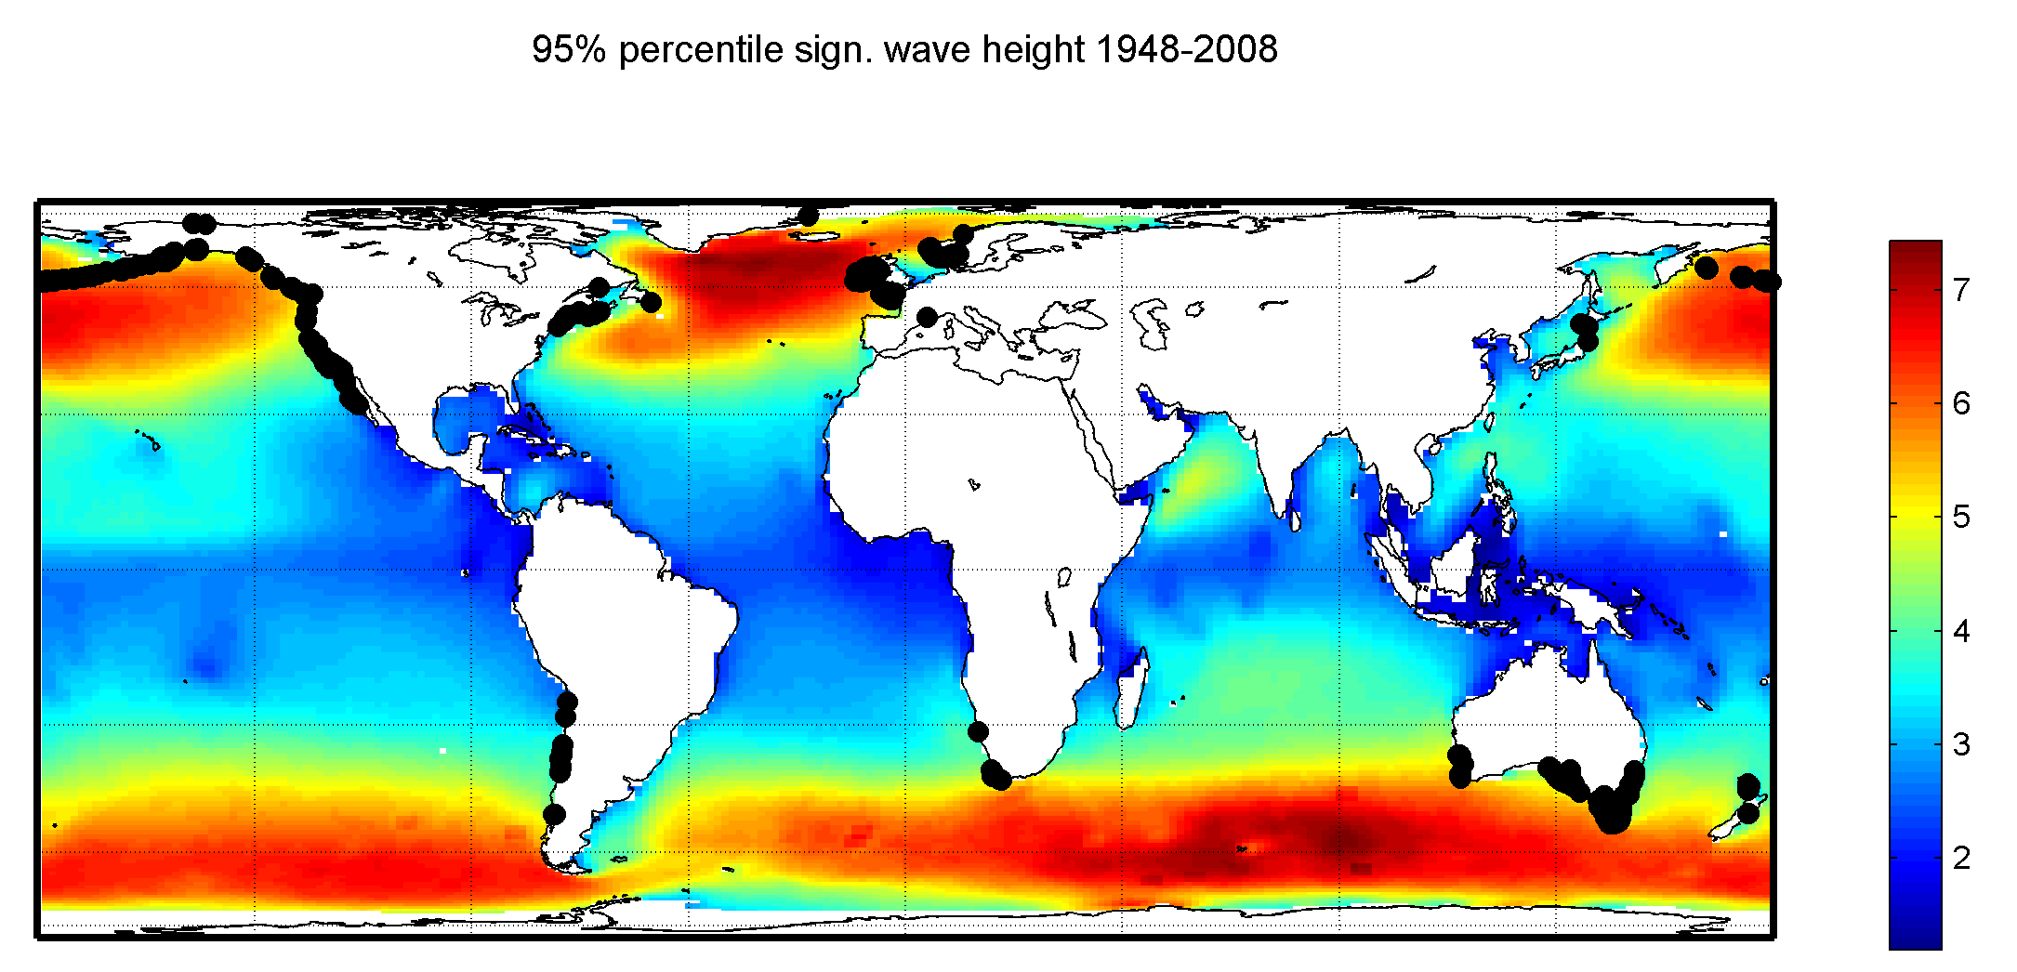

Fig1. 95% percentile of wave height (m) and location of kelp forests

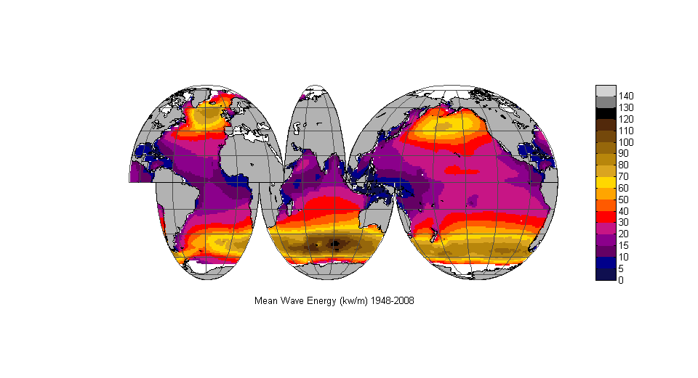

Fig2. Global Mean Wave Energy

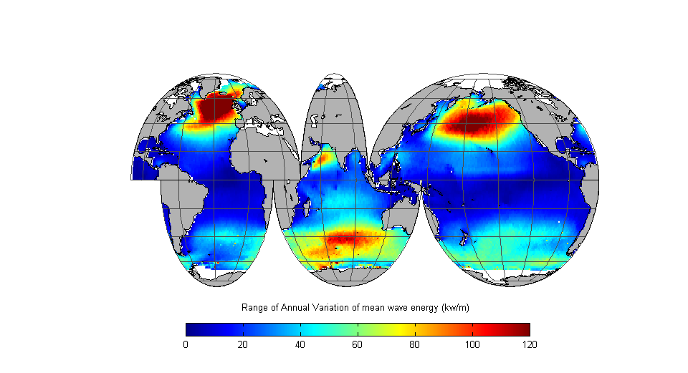

Fig3. Annual Range of variation in wave energy

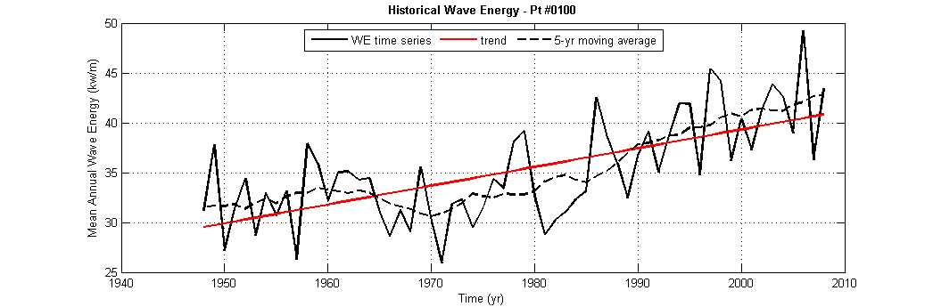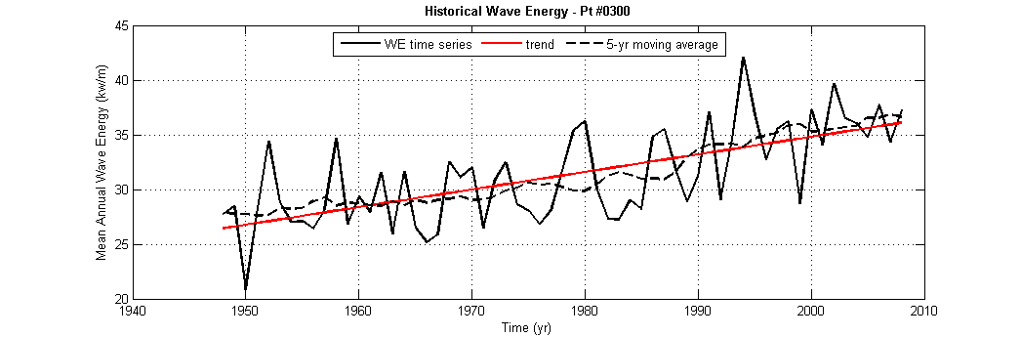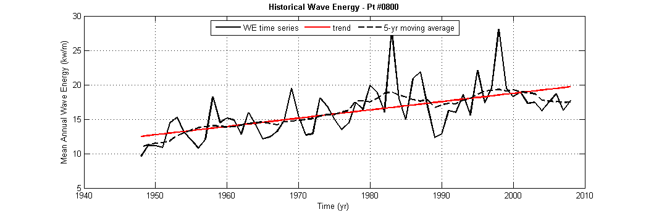

Fig 4. Sample time series of wave energy with long-term trends (red) and 5-yr moving average (dashed lines).

Some **takeaways**:

* Kelp forests face **the strongest swells zones** of the world. These extratropical storms areas are characterized by strong swells, strong interannual variation and the largest wave energy areas in the globe (Reguero et al., 2015). This definitely should have an effect on their growth, damage and recovery before, during and after storms
* Unlike other coastal ecosystems, kelp forests are located in areas where the **variation of wave energy within years is most strong**.
* We can observe the influence of interannual variability in the time series, for ex. El-Niño in the Pacific locations (see Fig 4, lower panel)

# References

Reguero, B.G., Losada, I.J., Méndez, F.J., 2015. A global wave power resource and its seasonal, interannual and long-term variability. Appl. Energy 148, 366–380. doi:http://dx.doi.org/10.1016/j.apenergy.2015.03.114

Reguero, B.G., Menéndez, M., Méndez, F.J., Mínguez, R., Losada, I.J., 2012. A Global Ocean Wave (GOW) calibrated reanalysis from 1948 onwards. Coast. Eng. 65, 38–55. doi:http://dx.doi.org/10.1016/j.coastaleng.2012.03.003